“THE REAL NFL!”
1 John 5:1, 4

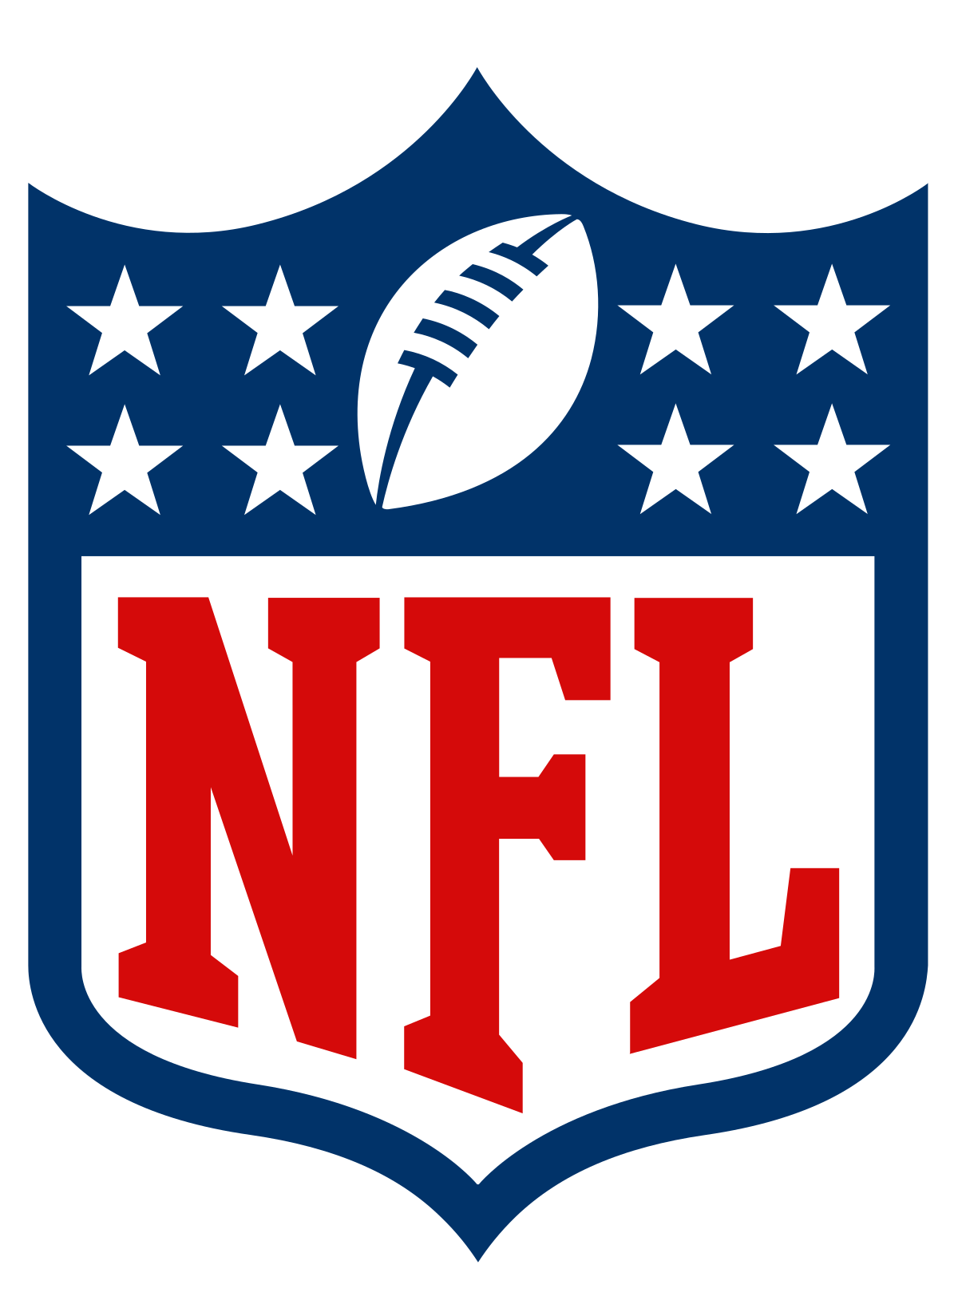
- INTRODUCTION
Happy Super Bowl Sunday! After 256 games, 16 games during a 17-week period, the Wild Card, Divisional, and Conference Championships rounds, only two teams remain standing. By tonight’s end, the NFL will crown a new Super Bowl Champion. Fans across the world will offer reasons why their team won’t hoist the Lombardi trophy. Some are legitimate while others amount to nothing more than excuses. But, whether it was a missed call, last-second play, or simply being outcoached and outplayed, fans will go into the offseason saying, “We’ll be back next year!”

Super Bowl Sunday arrests the attention of billions of people worldwide. But do the things of God arrest our attention in the same way!?!? Some of us schedule our lives around game time rather than dictating our schedules around GOD TIME! Believe it or not, God drafted and ordained you to be an owner in THE REAL NFL: NEW FAITHFUL LIVING!!! Too many of us are not performing or are underperforming in the game of life. This is not God’s will!!! God expects us to rise and soar to new heights and dimensions to win for the Kingdom’s sake and maximize our Kingdom-faith ownership status! Today’s message is simple: You’re a faith champion in the REAL NFL!!!

- FAITH ETHOS
- Do not be a faithless fool! Hebrews 11:6
- Workless faith is dead faith! James 2:14-17
- Big things come in small packages! Matthew 17:20
- God expects us to have childlike faith! Matthew 18:3

- FRANCHISES’ ETHOS
  - Cleveland Browns
  - Dallas Cowboys
  - Houston Texans
  - New England Patriots

- FREQUENCY EFFORTS
  - Each week, professional teams must report their players’ status.
  - Practice Status
- Did Not Participate
- Limited Participation: means less than 100% of a player’s normal repetitions.
- Full Participation: means 100% of a player’s normal repetitions.
  - Game Status
- Out – Will not play
- Doubtful – Unlikely to play
- Questionable – Uncertain if player will play

- FRUITLESS EXCUSES
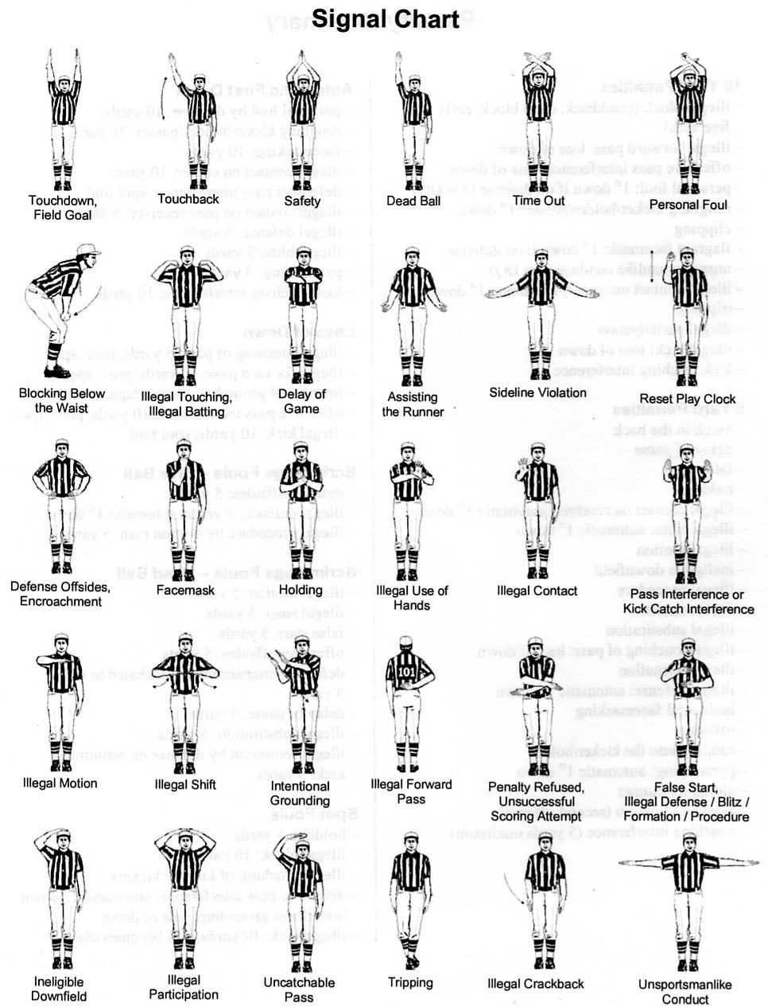

- FAITHFULNESS EXAMINATION

 | Marriage | Ministry | Marketplace
BROWNS
COWBOYS
TEXANS
PATRIOTS

- CONCLUSION
At times, we will experience seasons in our lives that mirror our favorite sports teams. As we experience the ebbs and flows of life, God expects us to live faithfully. Jesus is praying for us that our faith does not fail you! Regardless, you are God’s champion because Jesus Christ has given us the V-I-C-T-O-R-Y!!!

February 2-3, 2019
Sermon notes are available online at www.kingdombuilders.com and on the Windsor app
© 2019 Caldwell Ministries, Inc.
All rights reserved – No production of this material is permitted without expressed written permission of CMI

